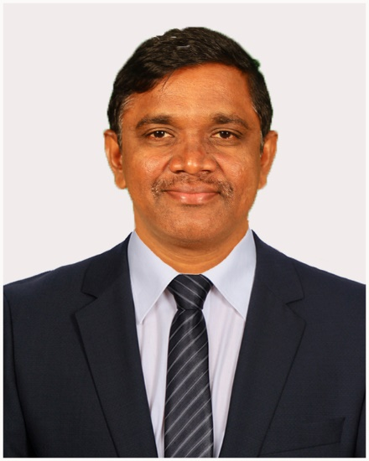 **SADE ADISESHAIAH**

**Contact: +9963717842,**

**E-mail:** [**asade@gitam.edu**](mailto:asade@gitam.edu)

**ORCIDID:** <https://orcid.org/0000-0003-3589-1256>

**SCOPUSID:** [**https://www.scopus.com/authid/detail.uri?authorId=57739105500**](https://www.scopus.com/authid/detail.uri?authorId=57739105500)

Mr. Adiseshaiah Sade (Ph. D. Thesis submitted) is an Assistant Professor of Fine and Performing Arts at GITAM, a deemed university in Hyderabad. Overall, 18 years of experience teaching art to students of diverse backgrounds and age groups. His students have widely differing aspirations and experiences as artists. The subjects of his paintings are drawn from his surroundings and reflect his life experiences. Portrays the rural environment of his childhood and the urban setting he lives in. Work has evolved with his growing awareness, self-exploration, and social concern. Recent work depicts everyday items that have a symbolic meaning in our lives.

Moreover, worked with a variety of media – watercolors, charcoal, oils, egg tempera, pencil, pen and ink, acrylic, paper Mache, and glass painting and experimented with traditional processes for the preparation of dyes and home handicraft recipes used in the villages of South India. Style has been shaped by the study of classical and tribal Indian art, including leather puppetry art, Madhubani, Warli, Kalamkari painting, and Pochampalli weaves.

Before joining GITAM, he earned UGC NET eligibility for assistant professor, a master’s degree in visual arts with a specialization in Painting, MA in Journalism and Mass Communication, and worked as an Assistant Professor in the fields of visual communication and Fine Arts at various universities. He was also a Professional artist and worked in the field of Visual Arts such as Painting Printmaking, Sculpture, etc. He is also a member of the Vijayawada Art Society, Andhra Pradesh, and a journal Editorial board member for the International Journal of Education, Culture, and Society.

|  |  |  |  |
| --- | --- | --- | --- |
|  |  |  |  |
|  |  |  |  |

He has published seven papers in National & International Journals and presented six papers at various International Conferences in various countries also with collaboration published six patents.